 

Delmarva-DC Statistics – June 2019

Top 25 – Tithes

Top 25 – Worship 000

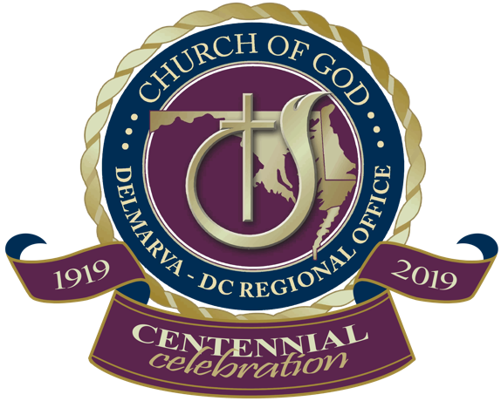

New Members

Prepared By: Andrea Veliz

For any concerns or corrections please email: info@cogdelmarva-dc.org